

RAFFLES INSTITUTION (JUNIOR COLLEGE)
PRELIMINARY EXAMINATION 2009

HIGHER 3

PHARMACEUTICAL CHEMISTRY 9812/01

Paper 1 28 September 2009

2 hour 30 minutes

Additional Materials: Answer Paper
Data Booklet

READ THESE INSTRUCTIONS FIRST

Write your index number, civics tutorial group and name on the Cover Page and all the writing paper you hand in.
Write in dark blue or black pen on both sides of the writing paper.
You may use a soft pencil for any diagrams, graphs or rough working.
Do not use staples, paper clips, highlighters, glue or correction fluid.

Answer any five questions.
Begin each question on a fresh sheet of paper.
At the end of the examination, fasten all your work securely together.

The number of marks is given in brackets [ ] at the end of each question or part question.
You may use a calculator.
You are reminded of the need for clear presentation in your answers.

This document consists of 16 printed pages.
Name |  |  |  | Index Number | CT Group
 |  | RAFFLES INSTITUTION (JUNIOR COLLEGE)  PRELIMINARY EXAMINATION 2009  HIGHER 3  PHARMACEUTICAL CHEMISTRY |  |  | 9812/01
Attach this Cover Page on top of your answer script.

 | Question Number  (Please circle the questions you have attempted.) |  | Marks
 | 1 |  | / 20
 | 2 |  | / 20
 | 3 |  | / 20
 | 4 |  | / 20
 | 5 |  | / 20
 | 6 |  | / 20
 | Total |  | / 100

1 Sulfonamides, or sulfa drugs, are bacteriostatic. They do not kill bacteria, but merely stop them from growing and dividing.

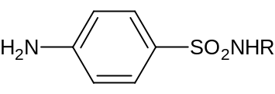

sulfonamide

The R group can be varied by incorporating a large range of heterocyclic or aromatic structures. Varying the R group affects the solubility of sulfonamides or the extent to which they bind to plasma protein, but not the mode of action of the drug.

(a) Sulfapyridine is a good antibacterial drug, but its solubility in water is very pH dependent.

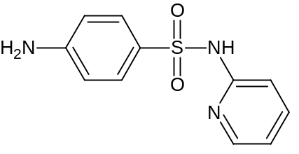
sulfapyridine

(i) Outline the mode of action of sulfapyridine. [2]

(ii) Explain why sulfapyridine does not affect human cells. [2]

(iii) Use the concept of solubility to suggest why sulfapyridine is no longer prescribed for treatment in humans. [2]

(b) When sulfapyridine interacts with its target receptor, the binding interactions are non-covalent in nature.

(i) Describe three important types of interaction that take place at the receptor site inside the human body. [2]

(ii) Identify the groups on sulfapyridine that are capable of making the three types of interaction you have given in your answer to (b)(i). [2]

(c) Devise a three-step synthesis for sulfapyridine, starting with acetanilide, C₆H₅NHCOCH₃, and chlorosulfuric acid, HOSO₂Cl, at 80°C.

You should specify the intermediates, reagents and conditions in each step. [3]

(d) Sulfonamide is the lead drug for the antidiabetic agent, tolbutamide.

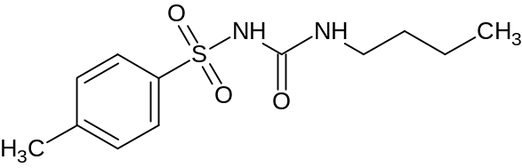
tolbutamide

The methyl group on the aromatic ring can be readily metabolised in the liver so as to make it hydrophilic, and more easily excreted in the urine via the kidney.

(i) Suggest the structure of the metabolite formed in the liver. [1]

(ii) State two other main metabolic reactions that the body uses in getting rid of drugs. [2]

(e) Gel electrophoresis can be used to analyse the mixtures of amino acids and small peptides obtained by the hydrolysis of proteins.

(i) Describe briefly how gel electrophoresis may be carried out. [2]

(ii) If a number of components in a mixture has similar electrophoretic mobilities, a complete separation may not be achieved.

Suggest two changes that can be made to the gel electrophoresis analysis in order to separate the components completely. [2]

2 Analgesics are drugs which relieve pain. The structures of four analgesics are shown below.
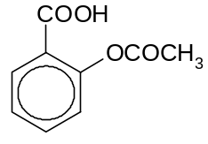
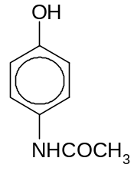
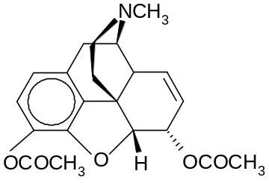
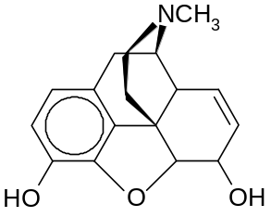
morphine
heroin
aspirin
paracetamol

(a) Classify the four compounds as narcotic and non-narcotic, explaining what these two terms mean. [2]

(b) Morphine acts as an agonist at the opiate receptor. Explain what the term agonist means. [1]

(c) A sample solution containing either morphine or aspirin was analysed using infrared spectroscopy. A selected portion of the IR spectrum of the sample is given below.
transmittance
transmittance

0.8
0.8

0.6

B
0.4
0.4
C

A

0.2
0.2

3600
3000
2000
1000
wavenumber/ cm^{–1}

(i) State the functional groups and the corresponding bonds whose stretching vibrations gave rise to the peaks A, B and C in the IR spectrum. [3]

(ii) Deduce the identity of the drug in the sample, giving a reason for your answer. [1]

(d) It is believed that codeine is converted to morphine in the human liver. Suggest reagents and conditions to convert codeine into morphine in a laboratory. [1]
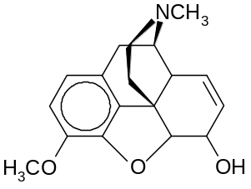

codeine

(e) A patient, who has a history of peptic ulcers, is running a fever and experiencing body aches. State, with reasons, why the patient should consider taking paracetamol, but not aspirin. [2]

(f) Aspirin and paracetamol are metabolised in the body at different rates. Several hours after the administration of an equimolar mixture of the two drugs, a sample of the patient’s blood serum was analysed in a spectrophotometer using cells which had optical path lengths of 1.0 cm. The following absorbances were measured.

wavelength/ nm | absorbance | lg (ε_{aspirin}/ mol^{–1} dm³ cm^{–1}) | lg (ε_{paracetamol}/ mol^{–1} dm³ cm^{–1})
240 | 0.433 | 3.55 | 4.01
280 | 0.096 | 2.80 | 3.41

Use the data given to calculate the residual concentrations of the two drugs in the serum, and hence, determine which drug is metabolised faster. [3]

- Phenylbutazone is used on horses to alleviate pain arising from sprains and arthritis. It may be prepared from butyl diethylmalonate and diphenylhydrazine in the presence of an acid catalyst.

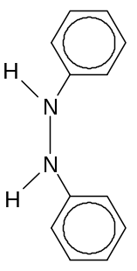
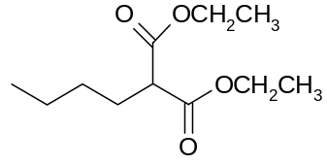
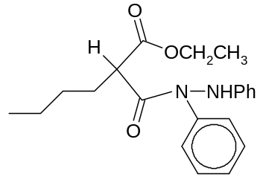
+
butyl diethylmalonate
diphenylhydrazine
phenylbutazone
H⁺
H⁺
intermediate X

Suggest a mechanism for the conversion of intermediate X into phenylbutazone. [3]

(h) The death of a certain music superstar was once rumoured to have been caused by an overdose of the analgesic called Demerol®, the hydrochloride salt of pethidine.
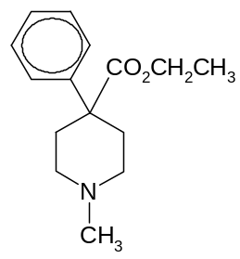
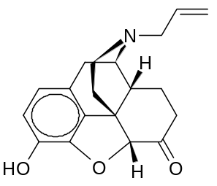
naloxone
pethidine

(i) Suggest why the administration of naloxone might save someone who has had an overdose of Demerol®. [1]

(ii) Using RCH₂CH=CH₂ to represent naloxone, draw the structural formulae of the optical isomers formed by reacting naloxone with bromine dissolved in an inert solvent. Assign the stereochemistry of each optical isomer using R, S configuration, giving reasons for your choice. [3]

3 Phencyclidine, which goes by the street name Angel Dust, is known to produce effects similar to those of lysergic acid diethylamide (LSD) and mescaline. The use of the illegal drug could be detected during urine screening of suspected users by mass spectrometry, which determines if PCAA, a metabolite of phencyclidine, is present.

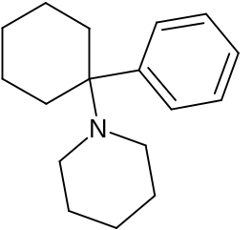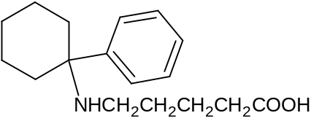

phencyclidine PCAA

(a) (i) Name the class of drugs to which Angel Dust, LSD and mescaline belong and state one effect of such drugs. [2]

(ii) Suggest why the presence of PCAA, rather than that of phencyclidine, is tested for during drug screening. [1]

Phencyclidine is a known antagonist to the N-methyl-D-aspartate (NMDA) receptor. The NMDA receptor allows for the transfer of electrical signals between neurons in the brain and in the spinal column. For electrical signals to pass, the NMDA receptor must be open. To remain open, an NMDA receptor must bind to glutamate and to glycine. A simplified diagram of the activated NMDA receptor is shown below.

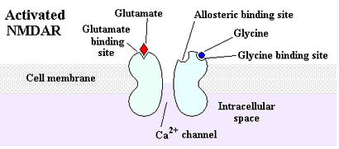

(b) (i) Explain what is meant by antagonist. [1]

(ii) By using a similar diagram, illustrate one way in which phencyclidine can act as an antagonist to the NMDA receptor. In your diagram, you need not show the actual structure of phencyclidine. [2]

(c) The USA Drug Enforcement Administration (DEA) Special Testing and Research Laboratory has recently received multiple reports of sugar cubes and blotter papers which may contain LSD. Upon testing, it is found that the samples do not contain LSD, but contain a potent drug known as Alpha-O. One of the two isomeric compounds shown below is the active ingredient in Alpha-O.

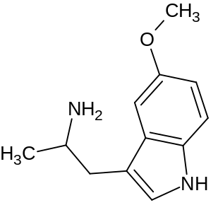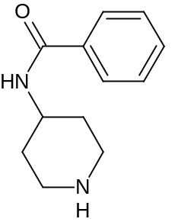

compound I compound II

To confirm the identity of the active ingredient, mass spectrometry is used.

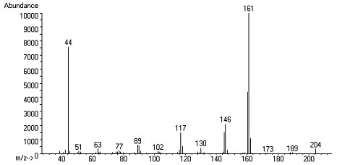

(i) Deduce the structures of the species that are responsible for the peaks at m/z values 146 and 161. [2]

(ii) Using your answer to (c)(i) and by giving one other reason, identify the active ingredient of Alpha-O. [2]

(d) Psilocybin, a drug in the same class as LSD and mescaline, occurs in a mushroom, Psilocybe mexicana. Psilocybin appears to be converted into psilocin as the active species in vivo.

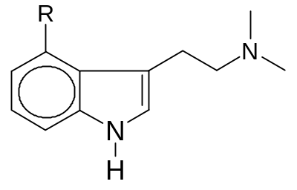
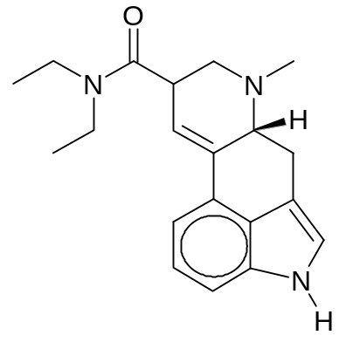
LSD
psilocybin:R = OPO(OH)₂
psilocin:R = OH

(i) Suggest what structural features psilocin and LSD have in common. [2]

(ii) Draw the Newman projection of the most stable conformer of psilocin. Give a reason for your answer. [2]

(iii) Psilocin is structurally similar to the central neurotransmitter, 5-HT.
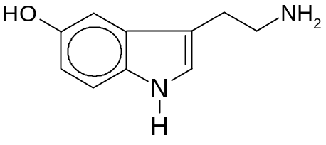

5-HT (also known as serotonin)

Suggest, other than spectroscopic methods, a chemical test to distinguish between 5-HT and psilocin. [2]

(e) Draw the structural formulae of all organic products formed when

(i) psilocin reacts with cold, dilute nitric acid, [2]

(ii) LSD reacts with hot, dilute hydrochloric acid. [2]

4 Stimulants are psychoactive drugs which induce temporary improvements in either mental or physical functions. They act on the cholinergic or adrenergic receptors, to which the neurotransmitters acetylcholine and noradrenaline bind respectively.

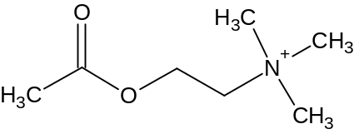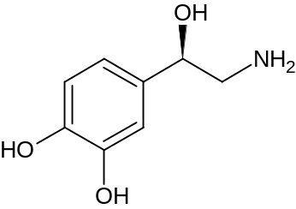

acetylcholine noradrenaline

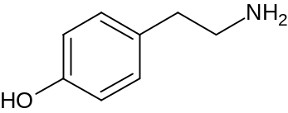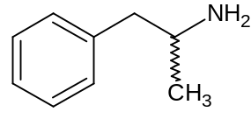

tyramine amphetamine

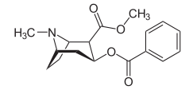

cocaine

(a) Tyramine and amphetamine are stimulants with no affinity for adrenergic receptors, despite their structural similarities with noradrenaline. The stereoisomer of noradrenaline also has reduced activity at the receptors. Based on the observations, what information about noradrenaline can you draw? [2]
(b) (i) Acetylcholine can be synthesized using chemicals that are readily available. However, it is not administered directly as a drug as it is susceptible to hydrolysis in aqueous medium, even without an acid or base catalyst. Suggest why acetylcholine has a higher susceptibility to hydrolysis than other esters. [2]
(ii) Acetylcholine is inactivated by the enzyme acetylcholinesterase, where a serine residue and a histidine residue (as shown below) are found to be binding sites for acetylcholine. One of the products formed is choline, [(CH₃)₃NCH₂CH₂OH]⁺. Suggest a mechanism for the inactivation of acetylcholine, showing how choline is produced. [4]

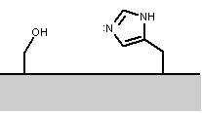 simplified representation of acetylcholinerase
(c) In drug synthesis, spectroscopy is used to characterise and identify the products.

(i) Suggest why stereoisomers of organic products may be distinguished by nuclear magnetic resonance spectroscopy but not infra-red spectroscopy. [2]

(ii) As the use of cocaine is illegal, analogues are used to achieve similar effects. Compound Y, C₉H₁₁NO₂, is a cocaine derivative which is used as a painkiller. Deduce the structure of Y using the ¹H NMR spectrum data given below. [5]

chemical shift / ppm | relative integral | multiplicity
7.849 | 2 | doublet
6.626 | 2 | doublet
4.305 | 2 | quartet
4.100 | 2 | singlet
1.354 | 3 | triplet

(d) To keep herself awake while studying for the H3 examination, a student drank three cups of coffee per day. After the examination, she found herself suffering from headaches if she did not drink at least a cup of caffeinated beverage each day. State and explain this phenomenon. [4]

(e) Ginkgo biloba is recommended as a substitute for caffeine to promote mental alertness. The following compound is one of the active ingredients in Ginkgo biloba. Copy the structure below onto your answer paper and assign E/Z notation to the isomer, where relevant. [1]

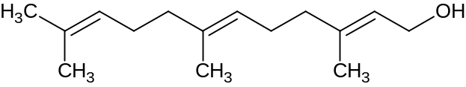

5 Zanamivir, the active ingredient of Relenza®, and oseltamivir, the active ingredient of Tamiflu®, are antiviral drugs. They inhibit the viral enzyme neuramidase, whose job is to “cut free” the newly formed virus from the host cell. Inhibition thus causes the particles to stick to each other and to the membrane of infected cells, thereby stopping the infection from spreading to other cells.

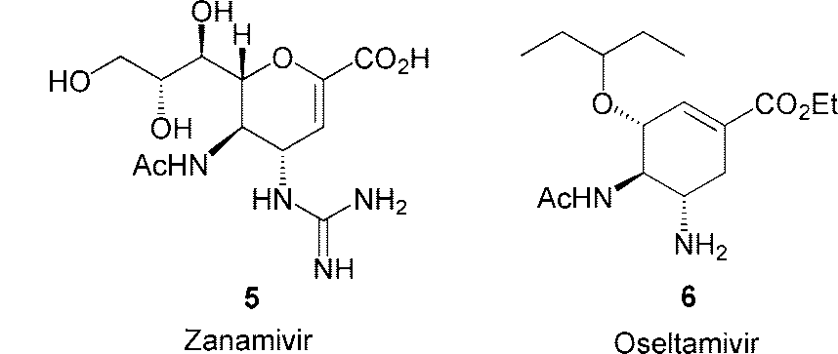

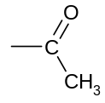

Note: The -Ac group represents this structure:

(a) Outline two other ways in which antiviral drugs act. [2]

(b) Explain why zanamivir may not be administered orally. [1]

A synthesis of zanamivir is detailed in the following scheme:

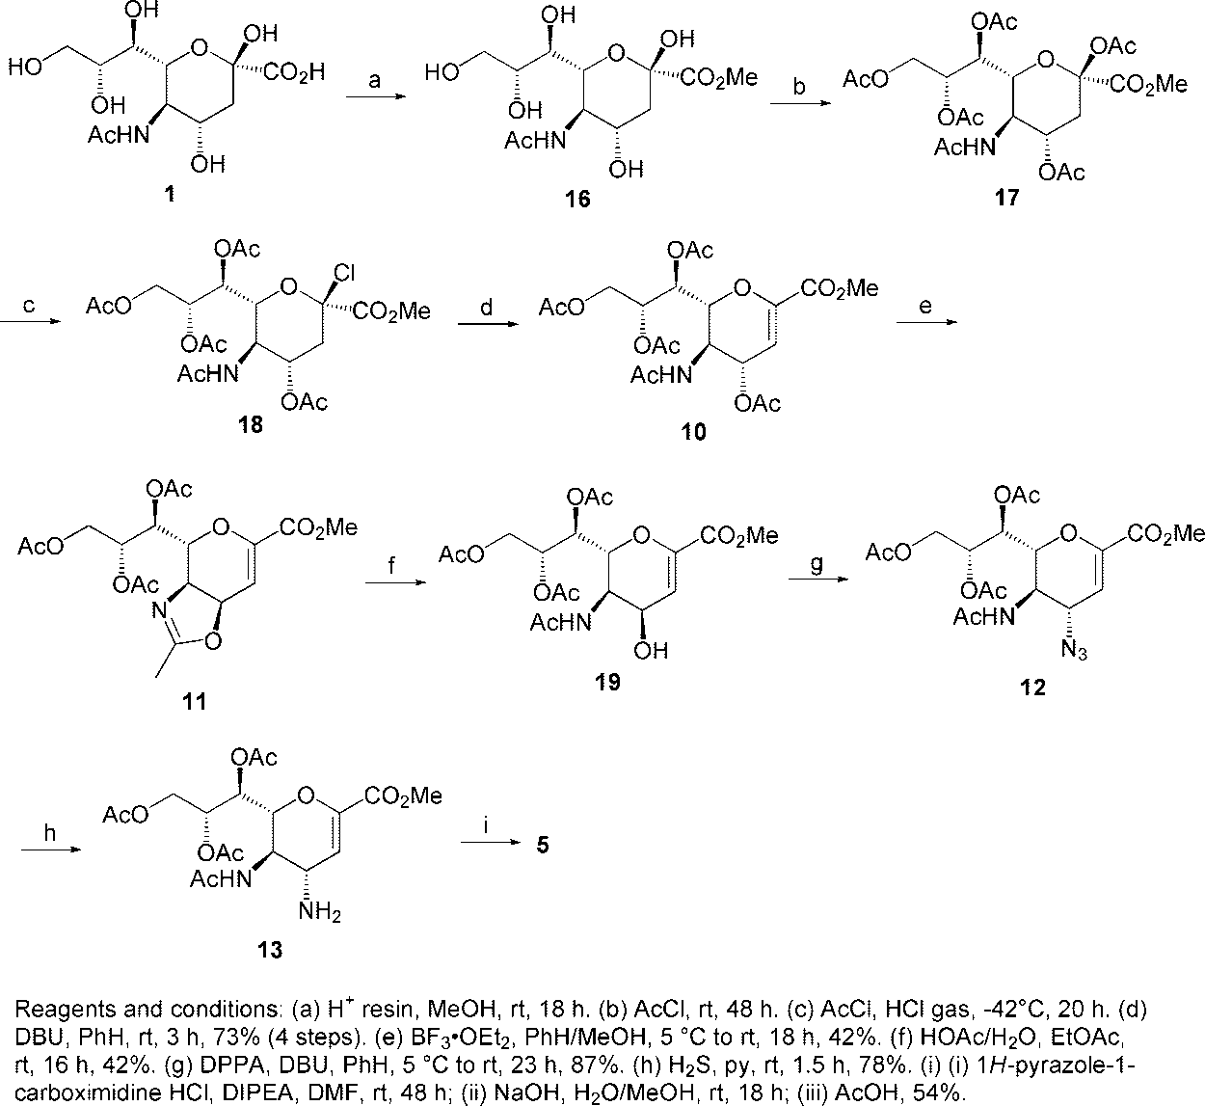
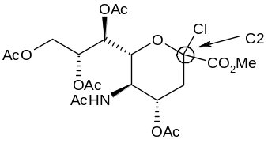
18
3
zanamivir

Reagents and conditions for steps: (a) H⁺, MeOH, rt, 18h (b) AcCl, rt, 48h (c) AcCl, HCl(g), –42 ºC, 20h (d) Base (e) BF₃, OEt₂, PhH/MeOH, 5 ºC to rt (g) DPPA, Base
(c) (i) In step c, HCl gas was used to carry out the substitution of the –OAc group at carbon 2 (C2). Outline the mechanism for this step.

You may represent the large side-chain on C6 as R. [3]

(ii) Explain why all the other –OAc groups were unaffected in step c. [2]

(iii) The intermediate 3 synthesised may have two stereoisomers at carbon 2 (C2), namely 2R-3 and 2S-3. Draw the respective structures of the two stereoisomers in their most stable conformations. [2]

(iv) Suppose step d follows second-order kinetics and requires the presence of a base. State which stereoisomer of intermediate 3 is most suitable for carrying out step d and outline the mechanism.

You may represent the base used as B. [3]

(d) Suggest the role of BF₃ in step e. [1]

(e) The reagent DPPA for step g has the structure shown below.

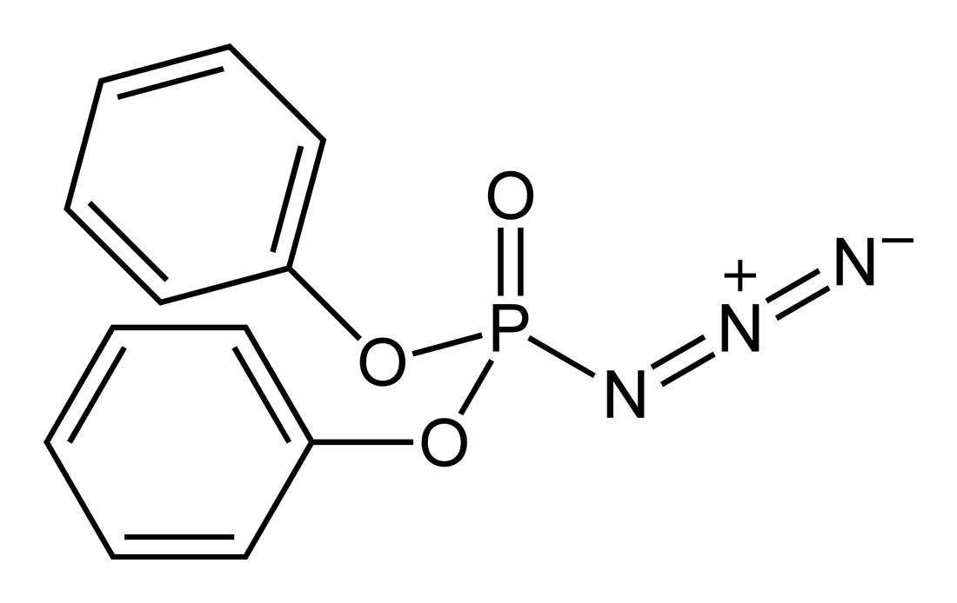

What type of reaction occurs in step g? [1]

(f) Why is it necessary to carry out steps a and b first? [2]

(g) Suggest how monoclonal antibodies can be used in drug therapy. [3]

6 This question involves heterocyclic compounds.

(a) NAD⁺/NADH is a biological redox system. The two compounds may be represented by the structures below.
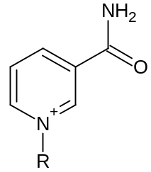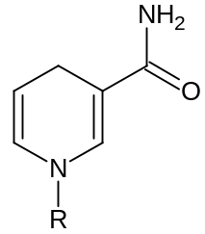

NAD⁺ NADH

(i) Classify the compounds as aromatic or non-aromatic. Explain your answer. [2]

(ii) Draw the structure of a tautomer of NADH. [1]

(iii) NAD⁺ contains ribose, two phosphate groups and adenine. The structural formula of D-ribose is HOCH₂CH(OH)CH(OH)CH(OH)CHO. Draw a Fischer projection of D-ribose. [1]

(b) The molecular structure of nicotine is shown below. The pK_{b} of N-1 is 10.88 and the pK_{b} of N-2 is 5.98.
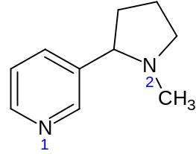
nicotine

(i) Draw the structure of the predominant form of nicotine that exists in blood. [1]

(ii) Compare the basicity of the nitrogen atom in pyrrole with that of N-1 in nicotine. Explain your answer. [2]

(c) State which spectroscopic technique you would use to distinguish between each of the following pairs of compounds. In each case, state the observations you would make.

(i)
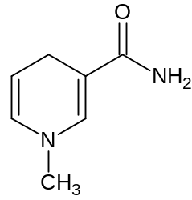 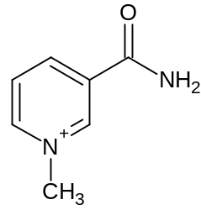 [2]

(ii)
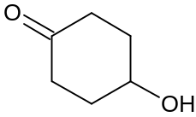 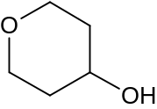 [2]

d) Porphyrins are derivatives of porphine, and natural porphyrins are highly essential for life, being essential components of heme and related enzymes. Metabolic diseases involving porphyrin and heme synthesis in humans are called porphyrias and cause profound symptoms.

Recently, porphyrin has been used in the area of supramolecular chemistry. A classic synthesis of a porphyrin derivative, TPP, is as follows:

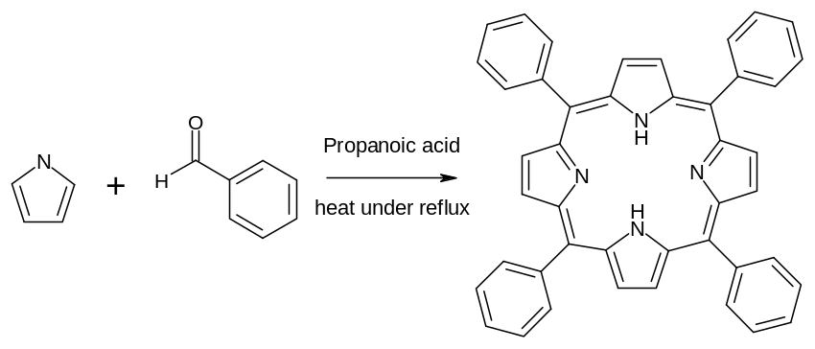
TPP

The synthesis takes place through a series of steps as shown in the following scheme.

Note that R represents phenyl group.

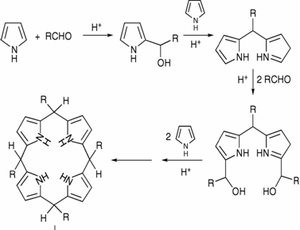
step 1
step 2
intermediate Z

+

+

(i) Outline the mechanism for the reactions in steps 1 and 2. [8]

(ii) Suggest the type of reaction that is required to transform intermediate Z to TPP. [1]

